**Artificial Intelligence and Health Application Series 1**

Artificial intelligence is gradually entering people's lives, and health is no exception. Listed below are several recently reported state-of-the-art technologies of artificial intelligence in health care, in order to provide a preliminary understanding of the current application and serve as a reference.

# International

## Switzerlands Oviva’s AI Nutrition Advice System

Artificial intelligence gives you the best nutritional advice.

Swiss digital health company Oviva with their academic partners has announced that it can analyze photos of people’s meals and prevent illnesses related to daily meals.



Oviva , a company based in Altendorf in the canton of Schwyz, Switzerland , is now using artificial intelligence (AI) technology to provide nutritional advice. Users who aim to stay healthy through the Mediterranean diet can film their daily meals in the app. Stavroula Mougiakakou from the University of Bern in Switzerland commented in a press release about Oviva : "The analytical system not only identifies individual foods and estimates their portion sizes, but also calculates the intensity of an individual's weekly adherence to the Mediterranean diet."

The AI-based system was developed and tested in a joint research project between Swiss digital health company Oviva , the ARTORG Biomedical Engineering Research Center at the University of Bern and the Institute of Epidemiology, Biostatistics and Prevention at the University of Zurich. The purpose of this automated feature is to motivate patients to actively work towards improving their eating habits over the long term. In addition, according to a recent research paper published in the professional journal "Natural Scientific Reports", this technology can also reduce the burden on nutrition experts, effectively prevent diet-related diseases, and save medical expenses.

Individual users can use Oviva 's app to record their physical activity and weight. In addition, the technology can be used for regular communication with nutrition experts and to provide users with educational content. According to the information provided, Oviva also works with statutory health insurance companies and national health systems.

## AI Based Rehabilitation Physiotherapy Equipment From Spanish Inrobics

Using Robots and Artificial Intelligence to Improve Health and Rehabilitation Physiotherapy

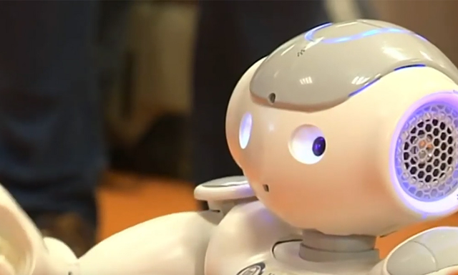

Inrobics Social Robotics, SLL, an independent company created and spun off from the research results of the Computer Science Department of the Universidad Carlos III of Madrid (UC3M) , has developed an artificial robot that can provide new sports and cognitive rehabilitation physiotherapy services in clinical and home settings.

The company's team developed a platform consisting of four basic elements : a robot that interacts with patients; an artificial intelligence system and a 3D sensor to control the robot; and a system that allows medical staff to set up treatments and conduct follow-up observations application as well as a cloud storage system containing all rehabilitation process information and analysis content. Fernando Fernández , associate professor in the Department of Information Sciences at UC3M and co-founder of Inrobics , said: “With 3D sensors, we can know every move of each patient at all times. For example, we can not only know whether the patient is raising an arm, but also whether it is raising an arm. Does the patient rotate the spine to make this behavior less difficult? All of this useful information will be recorded and generated into a clinical report."

The goal of the project : to improve rehabilitation physiotherapy through imitation-based activities and a range of restorative exercises, and to provide healthcare professionals with additional tools to optimize these sessions. "And for child patients, interacting with the robot is like playing with a toy. At any time, they feel that they are not going to the hospital for rehabilitation, but to play. This is the added value we provide. In addition, we can also optimize and provide content that is usually not available in physiotherapy due to a lack of equipment suitable for certain patient characteristics,” said Jose Carlos Pulido, founder and CEO of Inrobics .

In addition, the platform, co-designed by professionals in pediatrics (cognitive and functional diversity) and geriatrics (active aging and monitoring), serves as a telerehabilitation resource that is also suitable for home use, thereby contributing to family harmony and improving quality of life. .

Toledo 's National Paraplegic Hospital is the first center to conduct a clinical trial using the artificial intelligence device, which has been used on children with spinal cord injuries.

## The Magic Mirror of Canada’s New AI Company ( NuraLogix ™)

A "magic mirror" that can measure health risks by taking a photo of a person's face;

Canada's NuraLogix ™ company continues to optimize its Heart Magic Mirror™ mobile app. You can easily take a selfie for 30 seconds to conduct daily physical and mental health self-examination, using advanced technology to keep your health in your hands . !

"Mirror of the Heart": The rectangular display screen is like a mirror. When you sit in front of it, the display screen starts to detect your health through facial recognition. This scene does have a "mirror mirror, please tell me..." trance about it. After about half a minute, the display screen will display the health status of the person looking in the mirror. What is special is that the risk of cardiovascular disease, stroke risk, type II diabetes risk, fatty liver risk, etc. can be displayed in one photo. According to the staff, it mainly measures health indicators and disease risks through facial skin. Is that accurate? "It's okay. Someone took high blood pressure medicine in the morning, and it can also detect it. Someone was previously diagnosed to be at risk of diabetes, and after going to the hospital for a checkup, it turned out to be true."

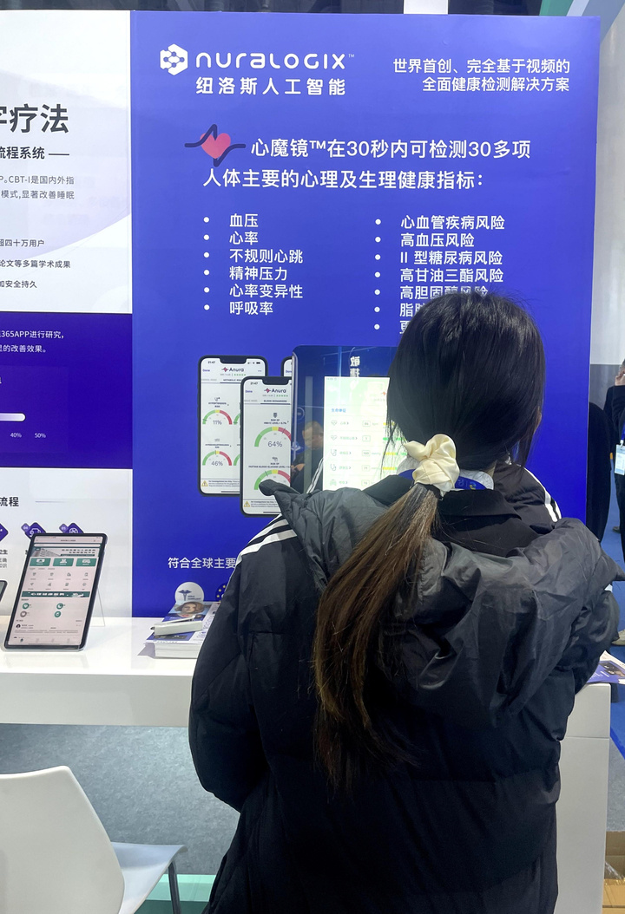

# China

## Zhejiang Provincial Health Commission’s Digital Health Person “Angel”

Very considerate to have such a smart accompanying doctor ? Do you also want to have one? Zhejiang digital health person “Angel”, created by the Zhejiang Provincial Health Commission, was unveiled. The mission of " Angel " is to allow everyone to have a dedicated digital family doctor who will accompany them throughout their lives. By using next-generation digital technologies such as artificial intelligence and big data, it provides residents with considerate services such as medical guidance, intelligent companionship, medication reminders, and medical record collection, which will bring new changes to medical and health service concepts, models, and methods.

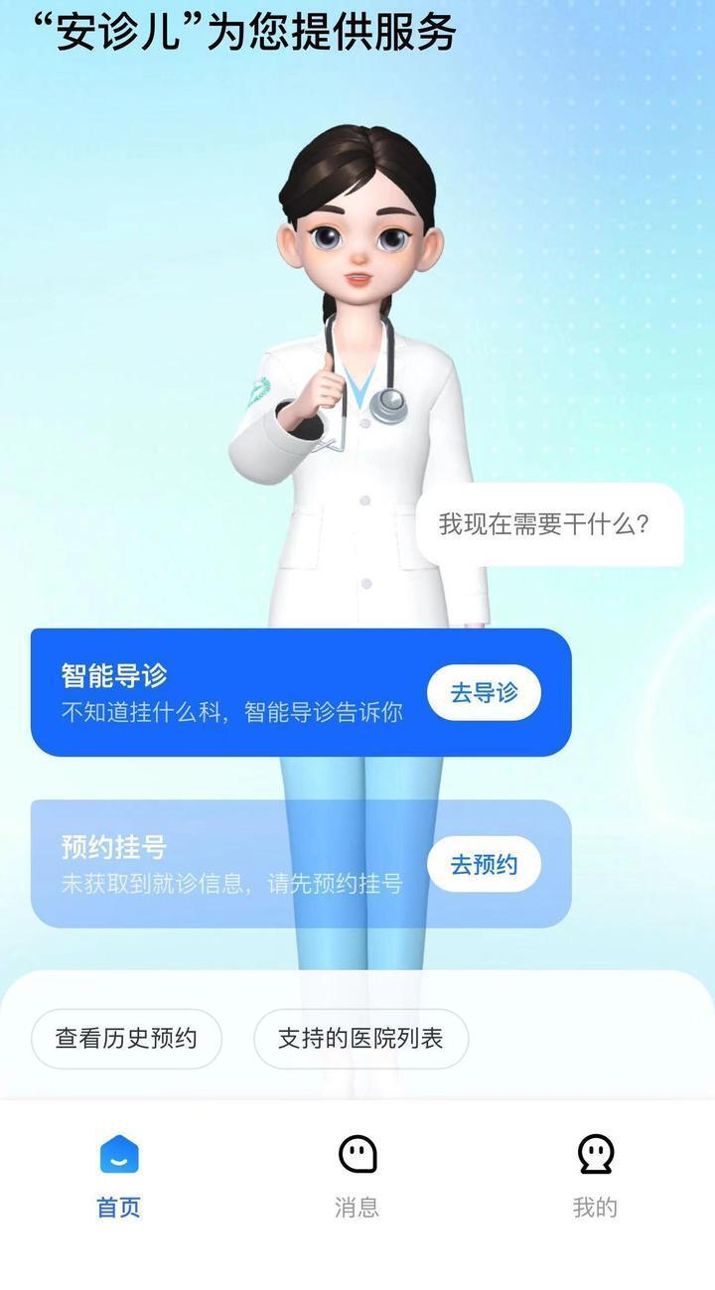

## AI Robot "Cloud Accompanying Diagnosis" at The First Affiliated Hospital Of Ningbo University

The "Cloud Accompanying Clinic" application just launched by the First Affiliated Hospital of Ningbo University is very eye- catching . Seeing a doctor alone is too lonely. The "handheld intelligent accompanying physician" with AI technology can accompany you to see a doctor. Find the "Cloud Accompanying Clinic" service below the official account of Ningda University First Hospital . Enter your symptoms in the dialog box. The intelligent accompanying clinician will guide you to enter your age and name, and automatically recommend doctors from relevant departments and remaining number sources for your consultation that day. . Before going, you can also ask "her" about the availability of parking spaces in nearby parking lots, so you don't have to worry about parking. When you arrive at the hospital, "she" can guide you to see a doctor, check up, get medicine, etc.

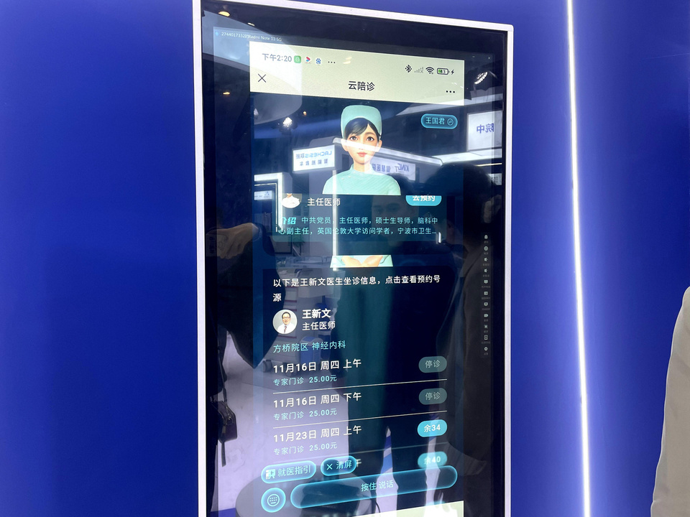

## Smart e- Health Station "Little House"

It can comprehensively measure your health status .

This smart e- health station allows people to stand and sit in the "little house", and various physical health indicators can be measured, such as height, weight, heart rate, blood pressure, blood oxygen, body fat, etc. Needless to say, The most convenient thing is that “when you have a physical problem and need to consult a doctor, it can help you connect with the doctor and make a judgment based on these examination results.

